Capstone Project

**Hotel Booking Analysis**

**Kushal Chakraborty**

**Data Science Trainee**

**Content**

* Importing and loading data of Hotel booking analysis
* Data cleaning
* Data preparation
* Data visualization
* Challenges
* Conclusion
* Suggestions

Data summary

Data set – Hotel booking analysis database includes information about

the hotels booked between the year 2015 to year 2017

Shape:

Rows – 119390

Columns – 32

Important columns- lead time, arrival date, no. of persons, repeated guest, no. of kids

Number of Bookings for various types of hotels

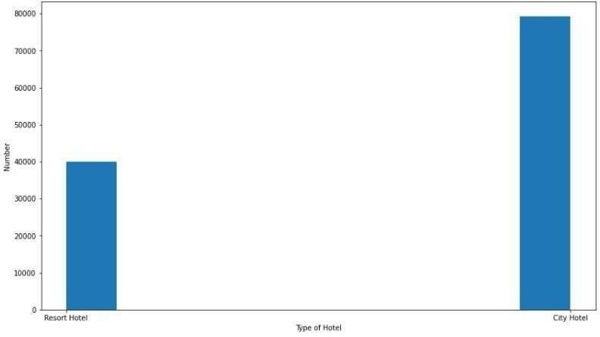

Plot between Type of market segment and Waiting

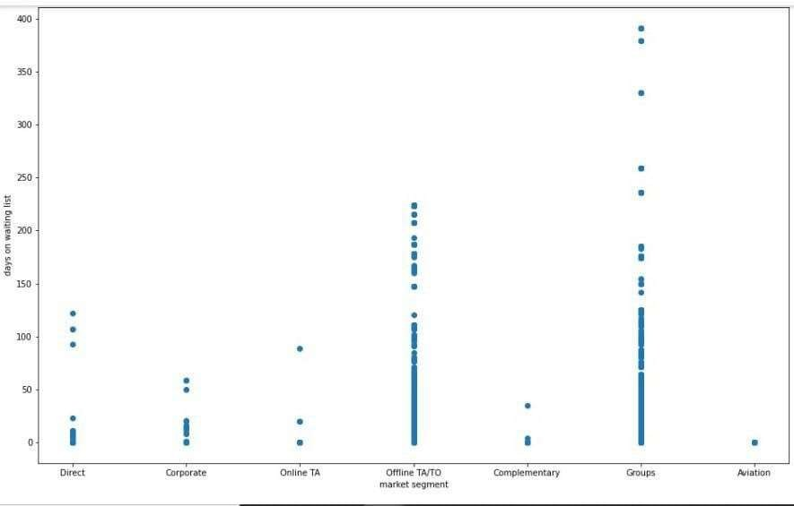list for **the** booking

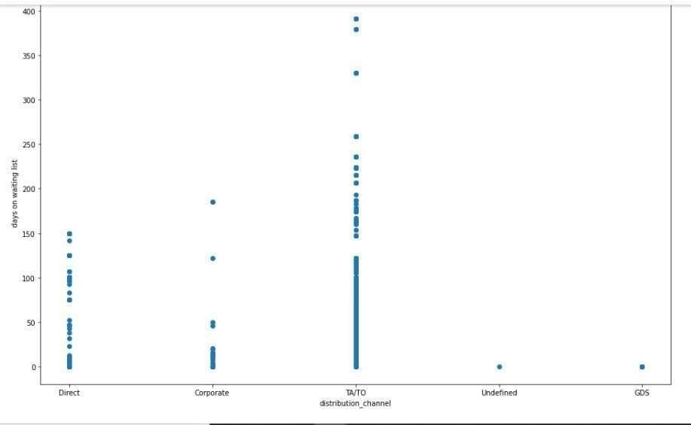Plot between Distributing Channel and Days on the waiting

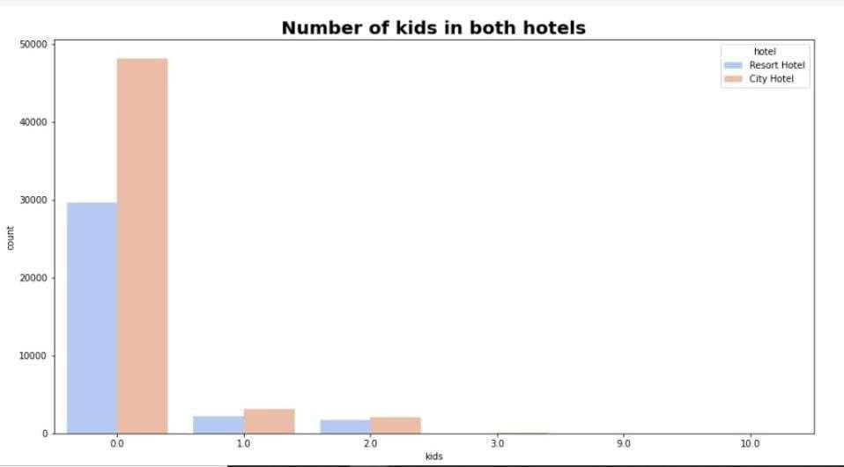Number of kids in both hotels

# Heatmap between type of Hotel and arrival month

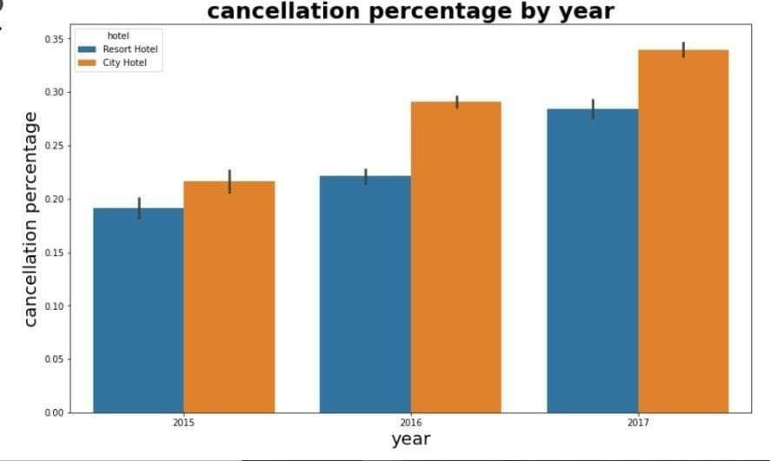Cancellation percentage by year

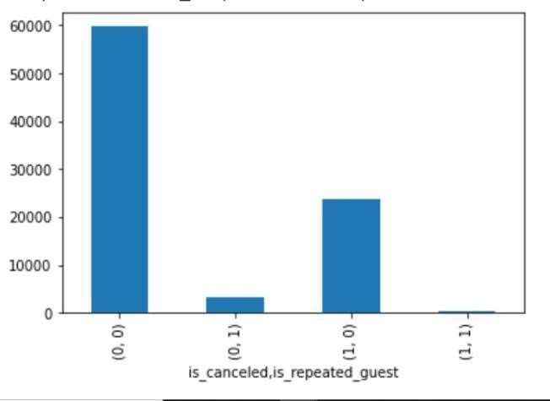Plot between cancellation type & repeated guest

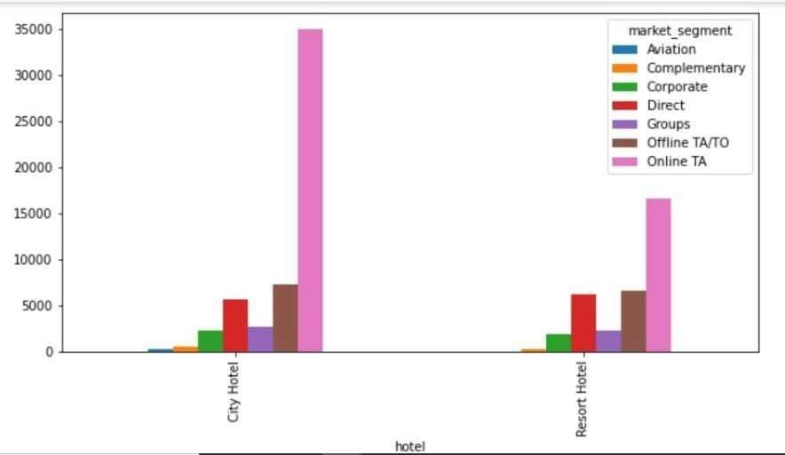Plot between hotel and market segment

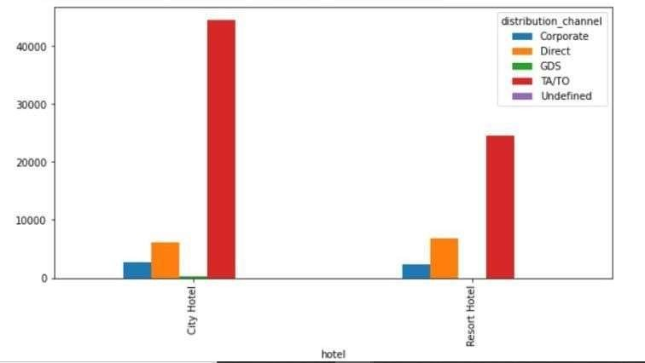Plot between hotel and distribution channel

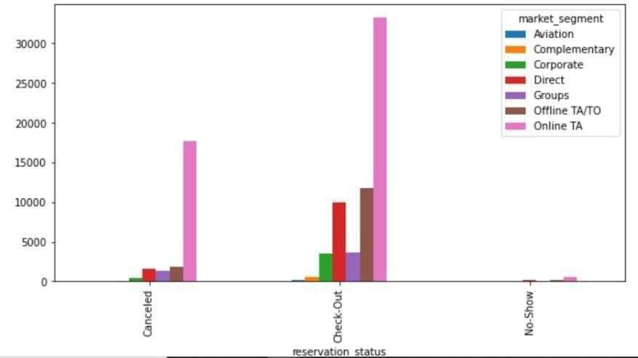Plot between resevation status and market segment

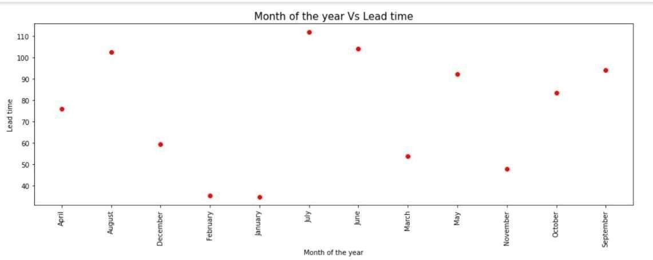Plot between Month of year & Lead time

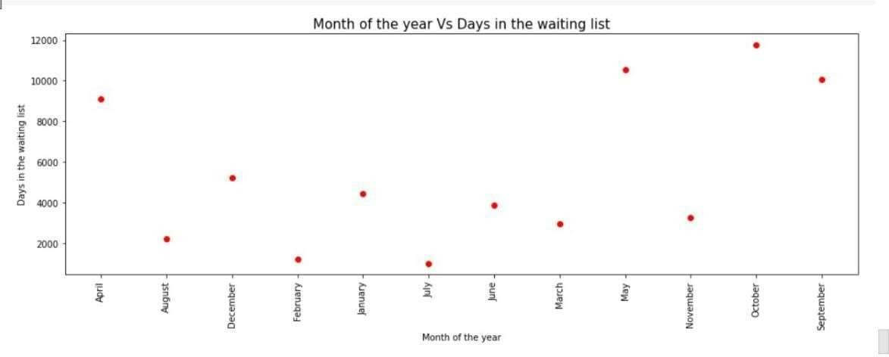Plot between Month of year & Days in the waiting list

# Heatmap - to show the relation between variables

CHALLENGES

* The name of the countries was not in the proper format,because of which we

are not able to plot the geomap plot

* Company and agent column has lots of duplicate value
* There were many rows with almost similar data
* Lots of null values in the dataset

CONCLUSION

* Month of August and july receives most no. of booking.
* Booking for city hotels is twice as for resort hotels.
* Repeated costumers cancel their hotel in very rare cases.
* Customers coming from aviation industry has very less time i.e. they book

urgently

* People with no kid prefer to choose city hotel over resort hotel

Strategies to counter high cancellations at Hotel

* Since we see, our repetitive costumers are most loyal costumers,to maintain them we can provide them with some bonus points,which can be redeem in the next booking
* Month of January and December receives less no. of booking,hotels can offer

discounted packages for these months.

* Family with kids prefer resorts , we can provide with holiday family packages.
* Great no. of the bookings are coming from travel agents, so we can provide

them some commission.

Thank You